Prelab – Lab 1

- Compile and bring to lab 1 a table of density corrections as a function of air temperature.

- For a stationary cylinder in air (freestream velocity = 30 m/s, air temperature = 72⁰F), plot differential pressure calculated from potential flow theory, 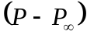, against angle (use equation ‘3’ in lab 1 handout).

- For the manometer given below, calculate the corresponding differential pressure (Note: temperature = 72 ⁰F, specific gravity of oil = 0.827).

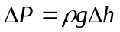 where 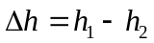.

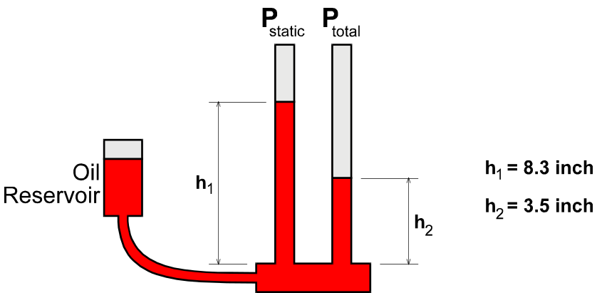

- If this differential pressure corresponds to the Pitot-Static probe dynamic pressure, use Bernoulli’s equation and the Reynolds number equation to calculate the corresponding freestream velocity and Reynolds number. (Note: base the Reynolds number on the cylinder diameter, 2 inches)

- Using the data series given below, calculate F_{D} and F_{L} using the discretized integral equations found in the Lab 1 handout (equations ‘9’ and ‘10’). (Note: cylinder diameter = 2 inches, cylinder length = 18 inches)

Angle (degs) | (N/m^2)
0 | 100
60 | -50
120 | -150
180 | -200
240 | -50
300 | 50

